Sales Performance Analysis

**Domain:** Ecommerce

**Reference line showing the Target Sales:**

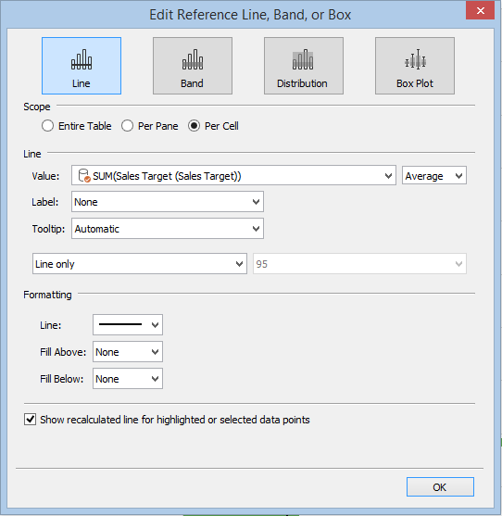

**Reference distribution showing 60%, 80% Target Sales:**

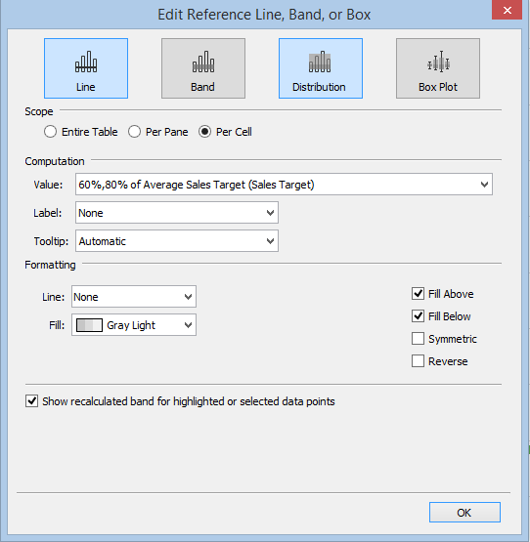

**Calculated field to compare and classify Target & Actual Sales:**

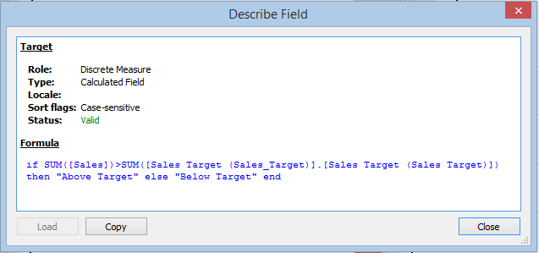

**Complete Visualization:**

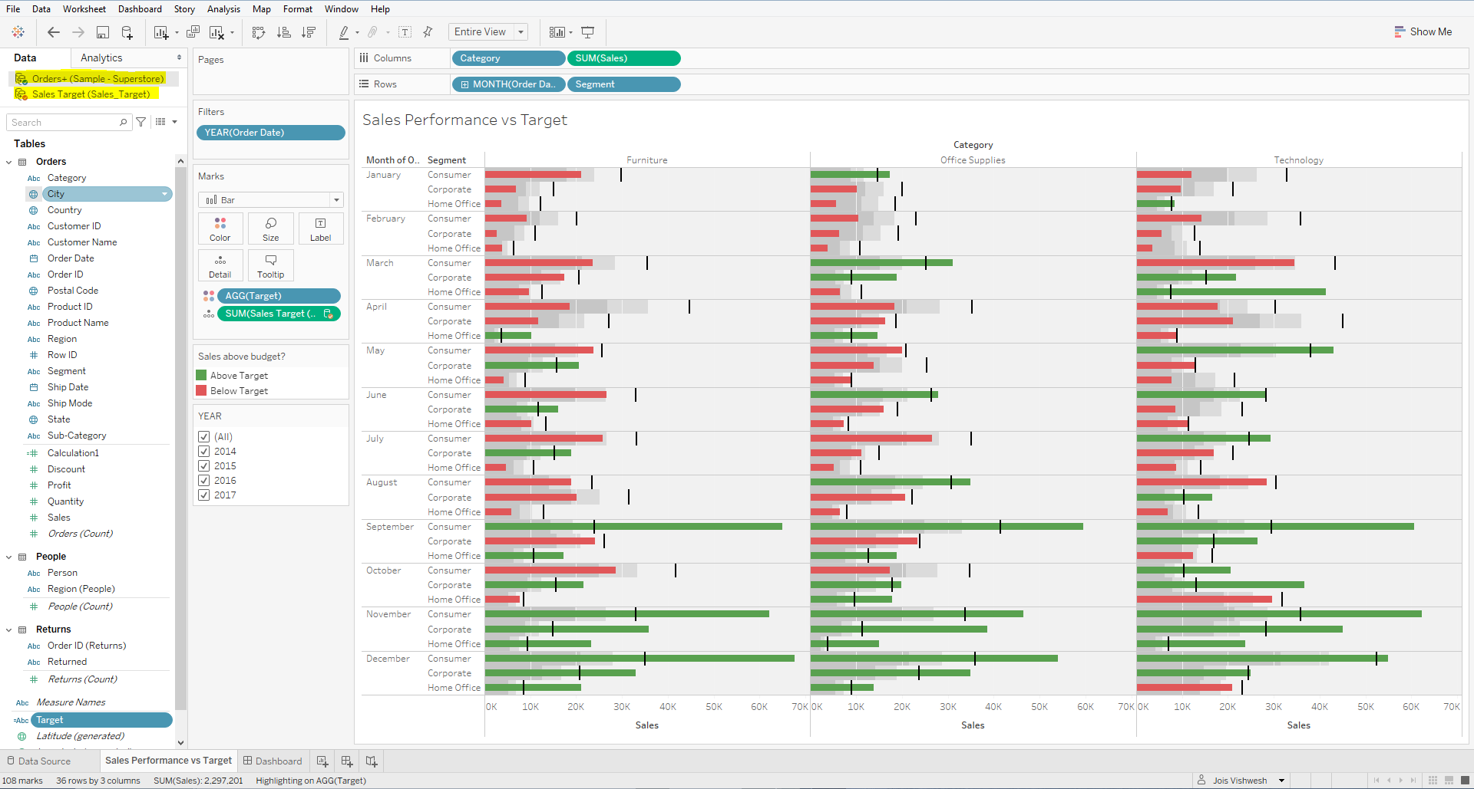

**FINAL SOLUTION:**

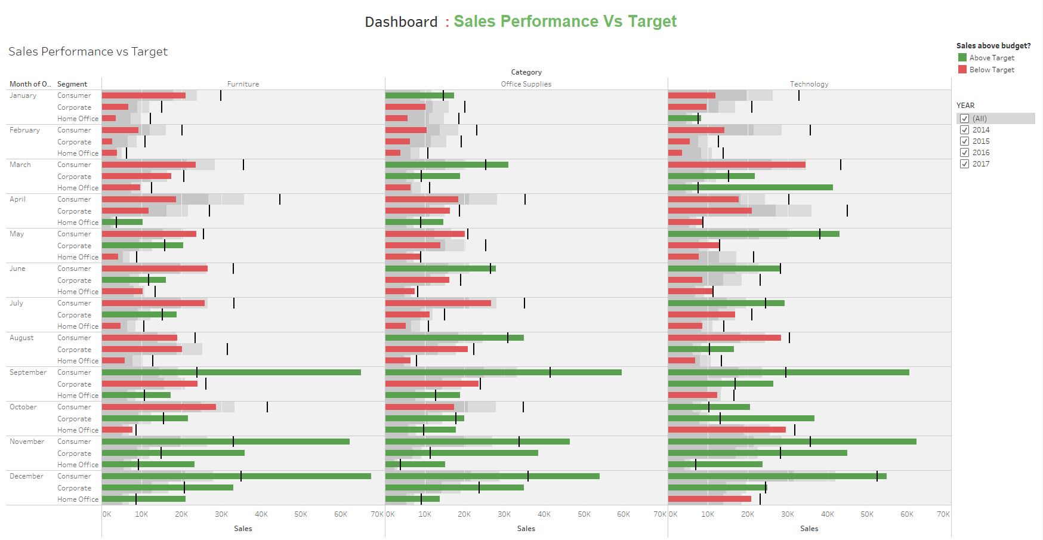[**Tableau project public link: Sales: Performance VS Target**](https://public.tableau.com/profile/jois.vishwesh#!/vizhome/SalesPerformancevsTarget_16020753289590/Dashboard?publish=yes)

<https://public.tableau.com/profile/jois.vishwesh#!/vizhome/SalesPerformancevsTarget_16020753289590/Dashboard?publish=yes>